**Create Build Pipeline:**

To perform continuous deployment, need to copy the files and publish to artifact.

An artifact is a deployable component of your application. It is typically produced through a Continuous Integration or a build pipeline. This means, Code once and share packages across different stages / environment (Dev, Test, UAT & Prod).

Go to the Pipelines tab, and then select Builds and click on continue.

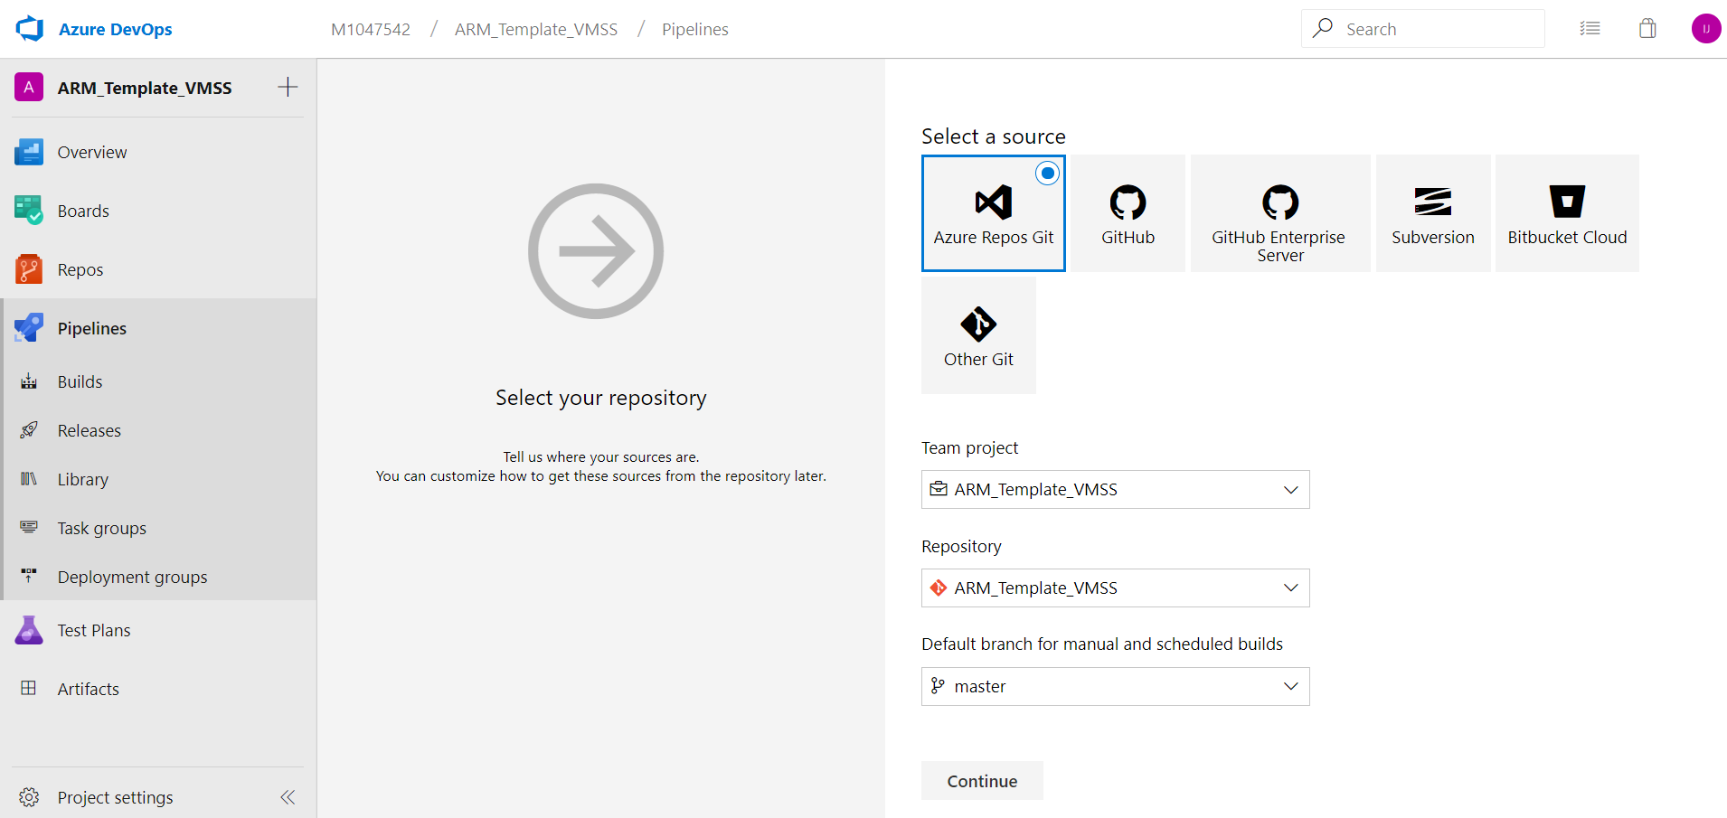

And then **create Empty job**

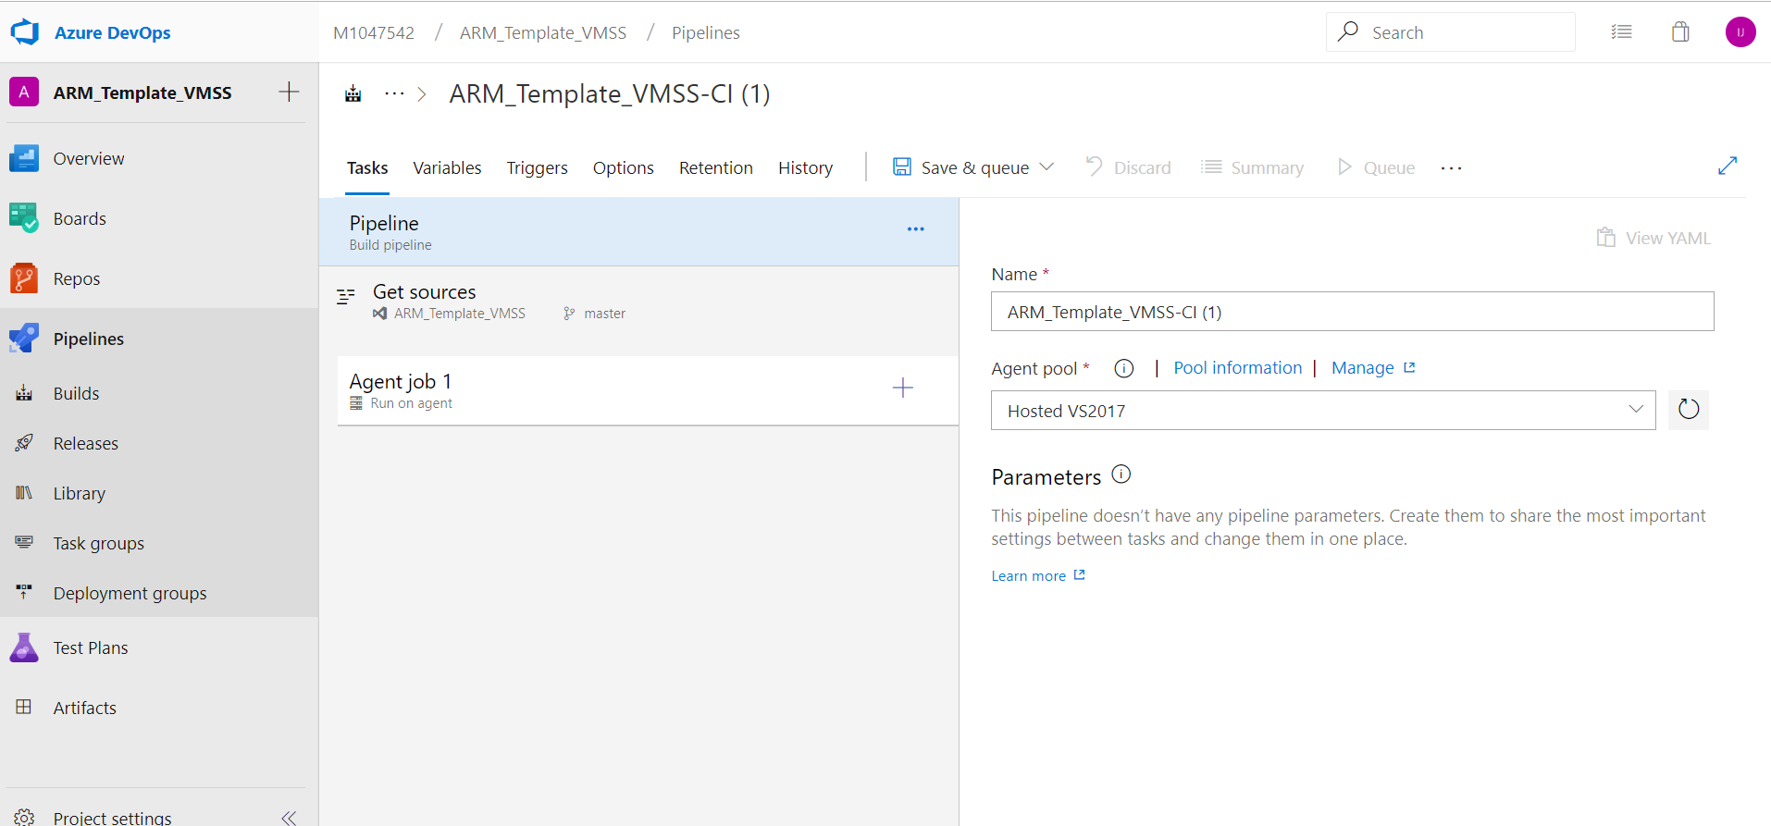

Click on + item on Agent Job

On the new pane, select Copy files and click ADD.

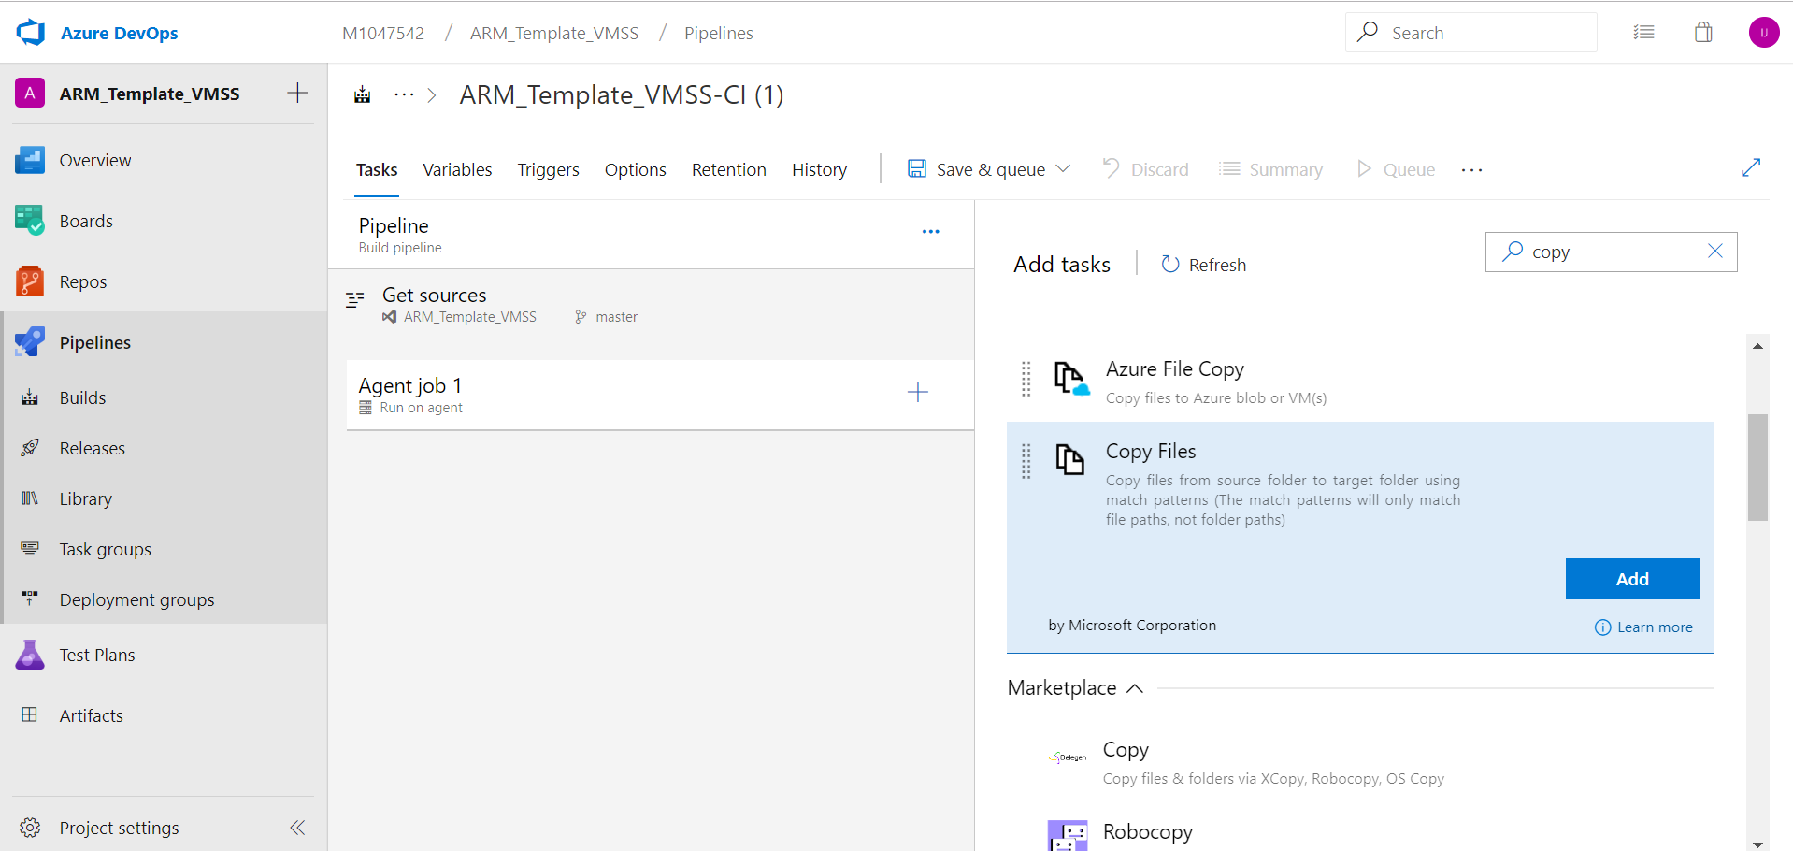

On the left pane, select copy files to: and fill required information:

Provide name for task

Select folder as: Azure template folder.

Provide target folder.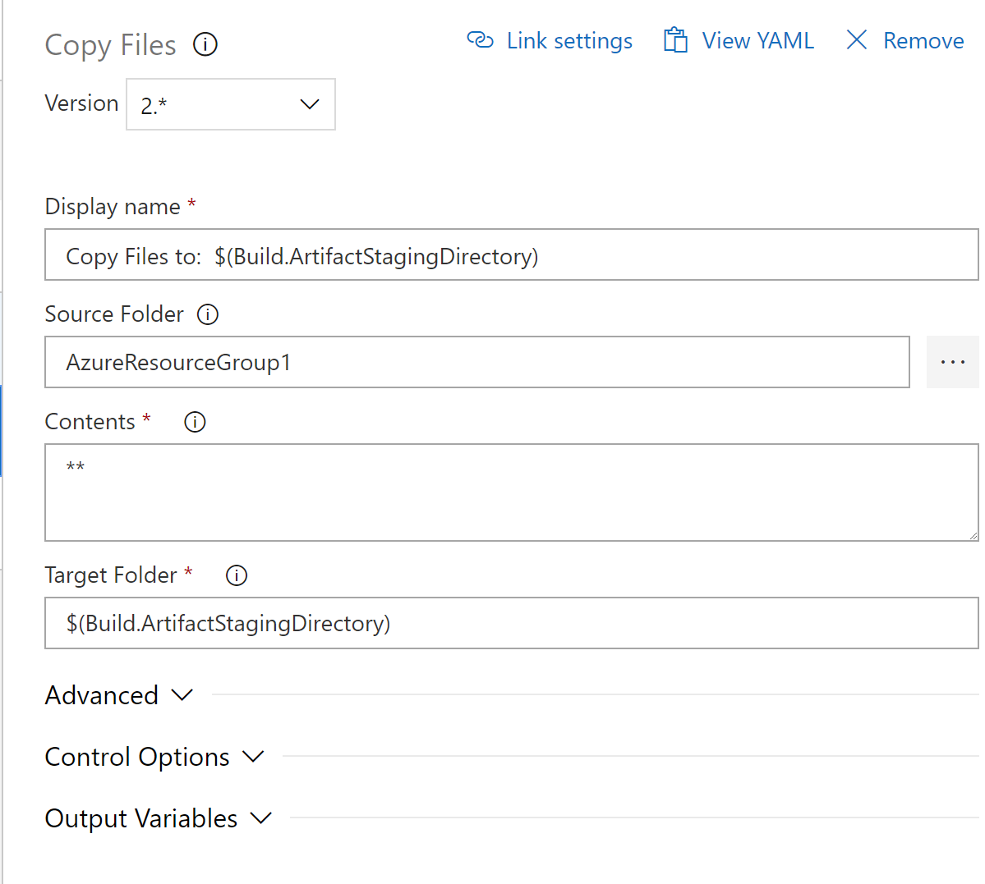

Next, we need to publish the Artifact.

Click on + item on Agent Job

On the new pane, select publish build Artifact and click ADD.

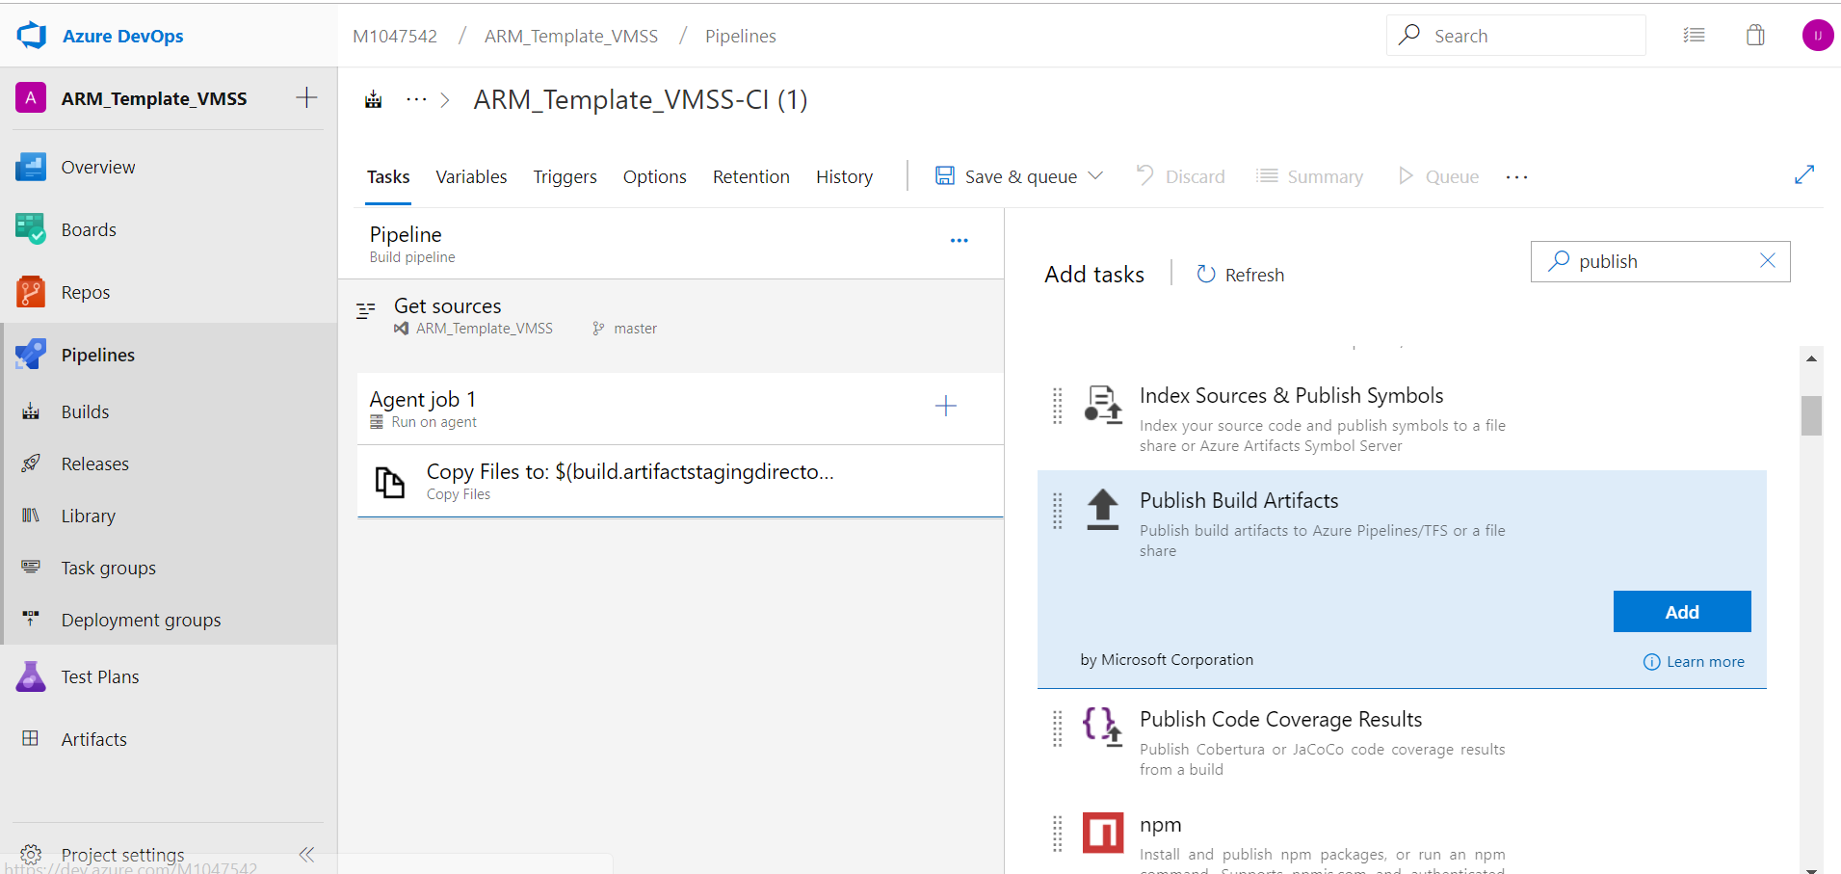

On the left pane, select Publish Build Artifacts: and fill required information:

Provide name.

Select path to publish.

Provide publish location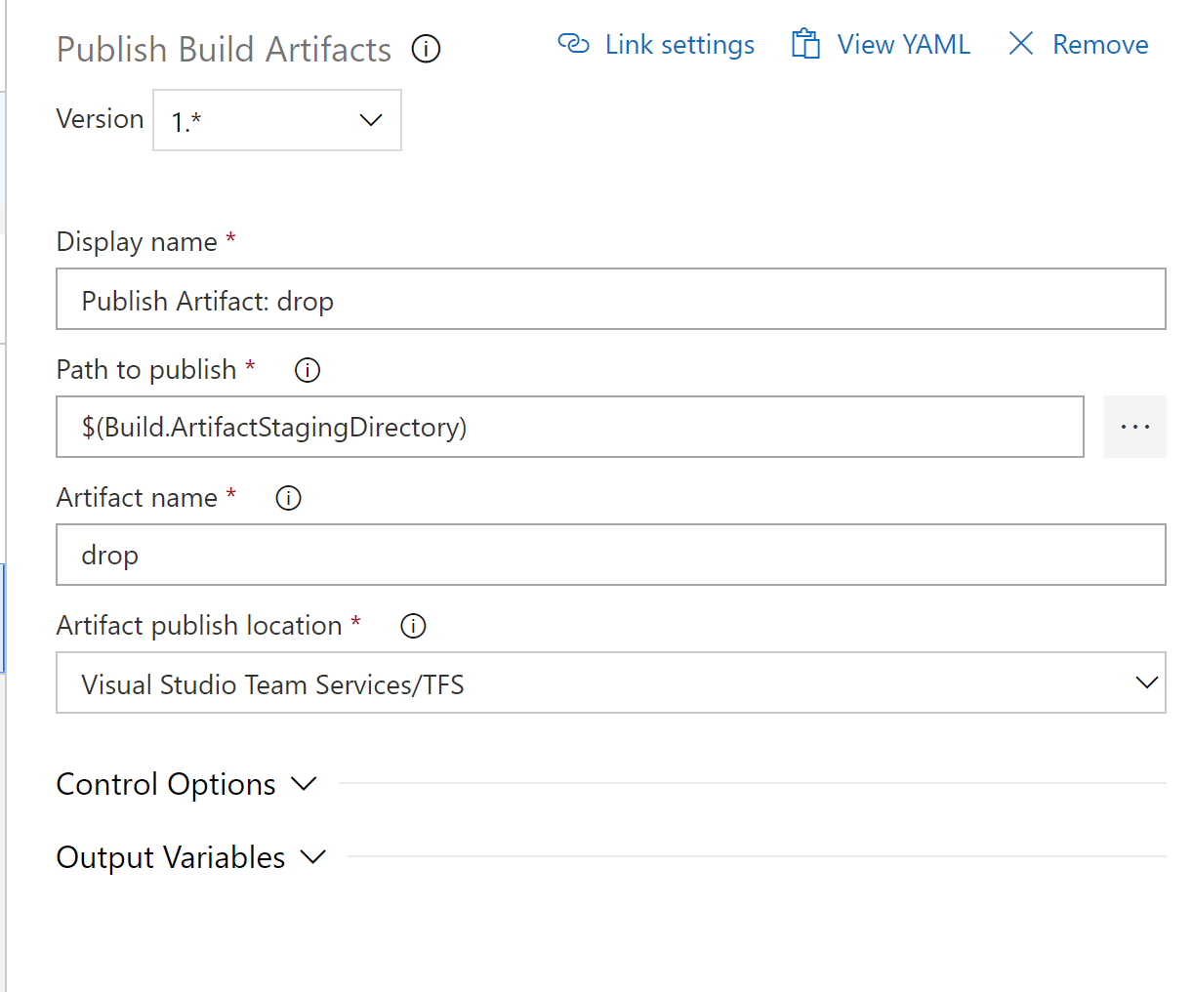

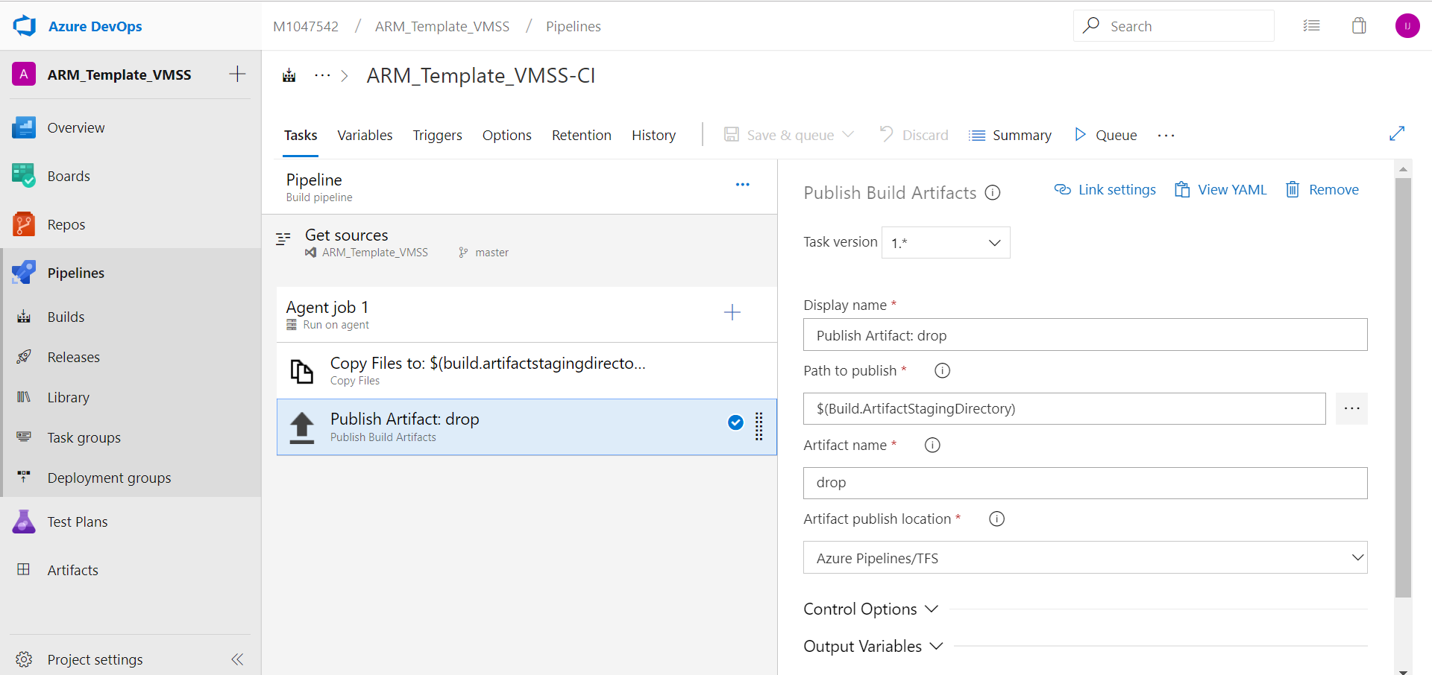

Click Save.

**Create a release pipeline**

A release pipeline is one of the fundamental concepts in Azure Pipelines for your DevOps CI/CD processes. It defines the end-to-end release pipeline for an application to be deployed across various stages.

Select the action to create a New pipeline. Then select Create a release pipeline.

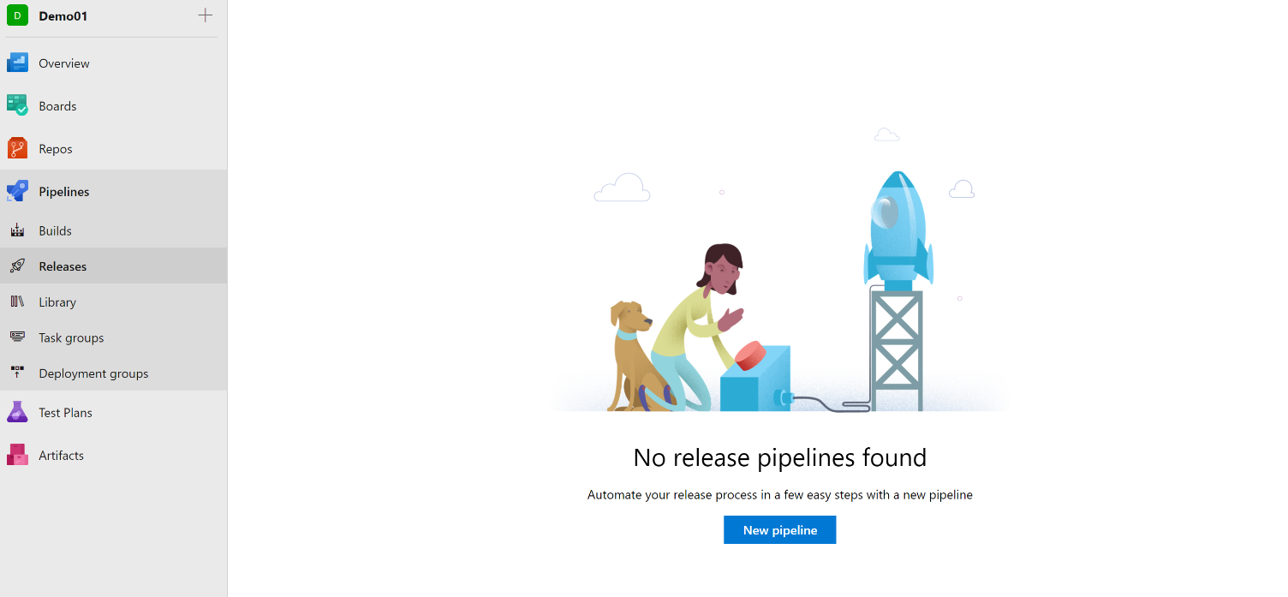

Select the action to start with an Empty job. Name the stage **Stage1 (Test).**

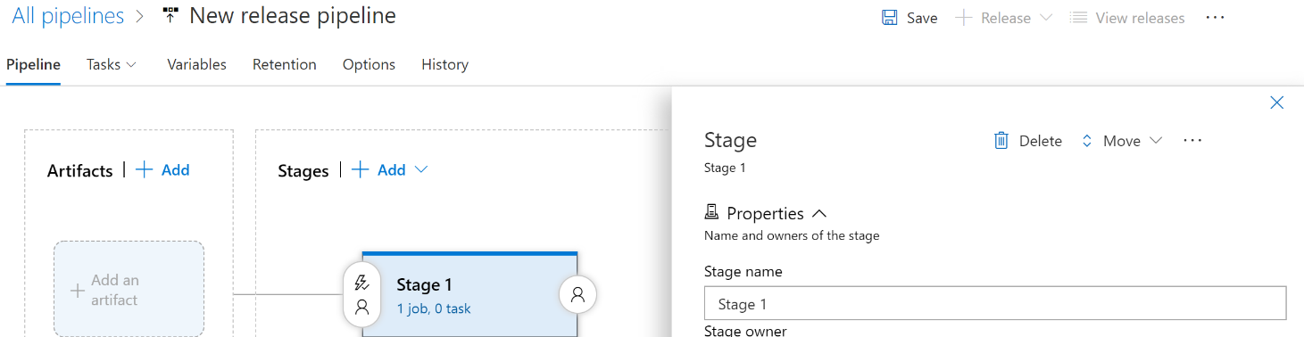

In the Artifact panel, select + Add and specify a Source (Build pipeline created earlier on this). Select Add.

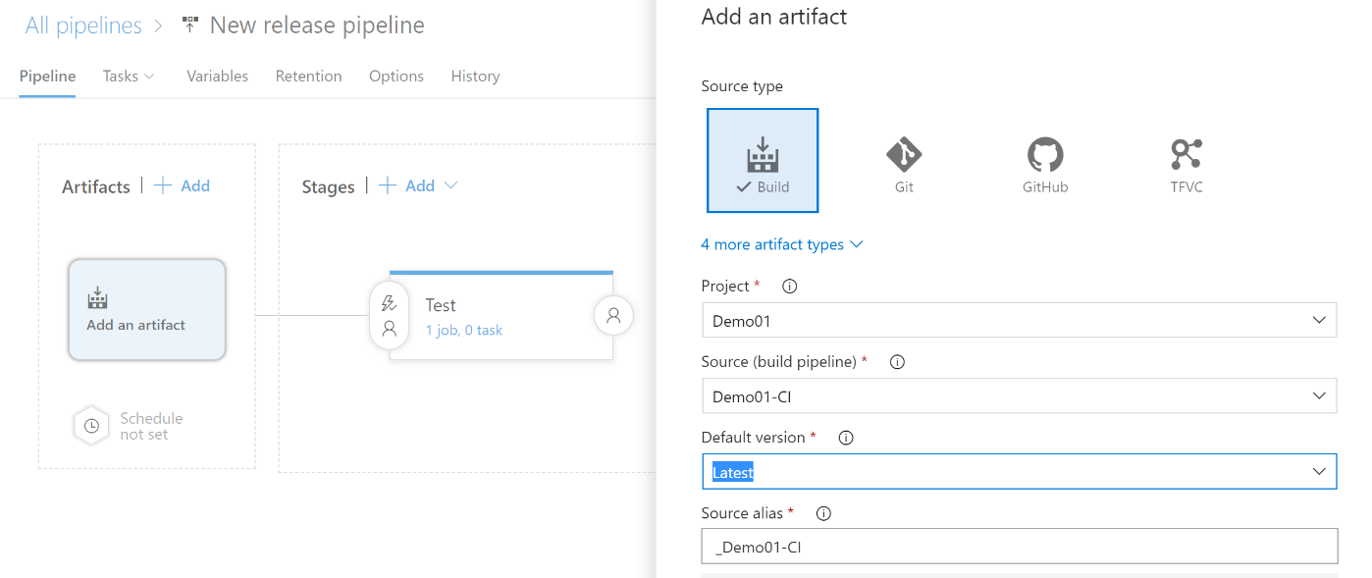

To enable the Continuous deployment trigger, click on Lightning bolt to trigger continuous deployment. You can specify any scheduled time for this deployment.

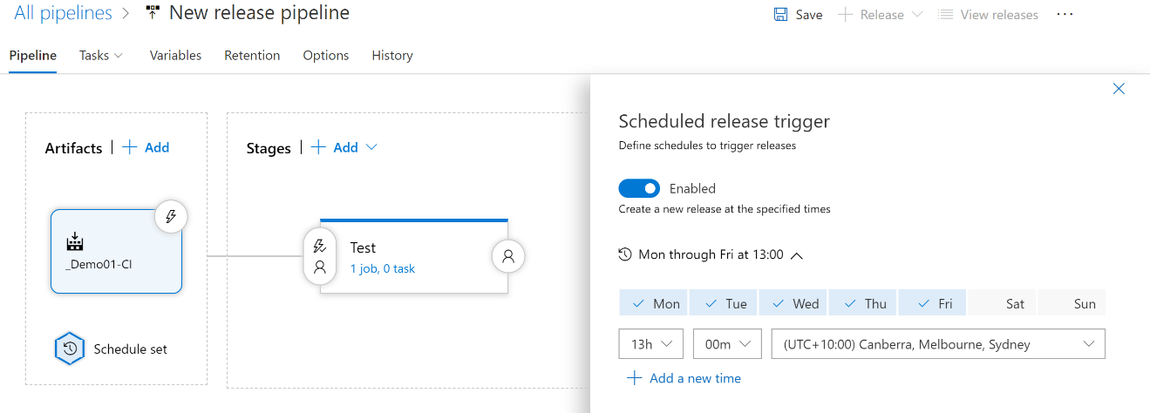

Select the Tasks tab and select your **Stage1 (Test)** Select the plus sign (+) for the job to add a task to the job.

On the Add tasks dialog box, select deploy and click on **Azure Resource Group deployment** and click ADD.

On the left pane, select **Azure Deployment: Create or Update Resource Group** action on:

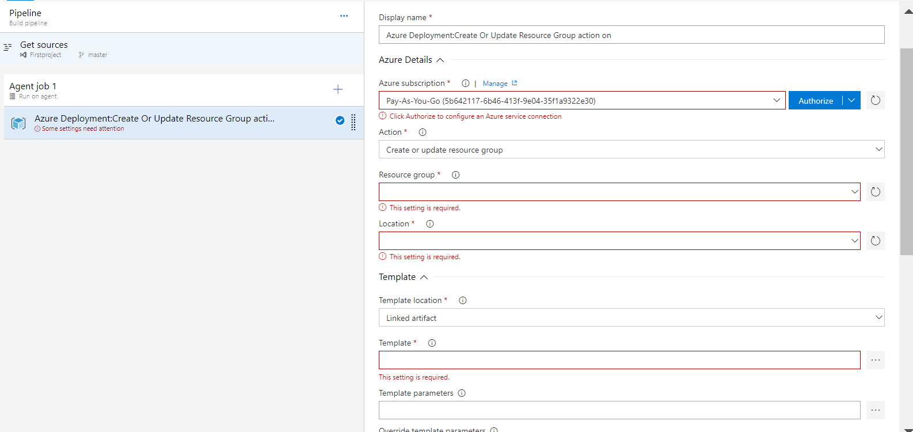

Select Azure Subscription and click on Authorize.

Select your resource group on your Azure subscription and location.

The template location will be linked artefact.

Select your template file (azuredeploy.json) from selection menu.

Select your template parameter file (azuredeploy.parameters.json) from selection menu.

Deployment mode: complete.

On the Pipeline tab, select the stage (Stage1 (Test)) and select Clone.

Rename the cloned stage (Stage1 (PROD)).

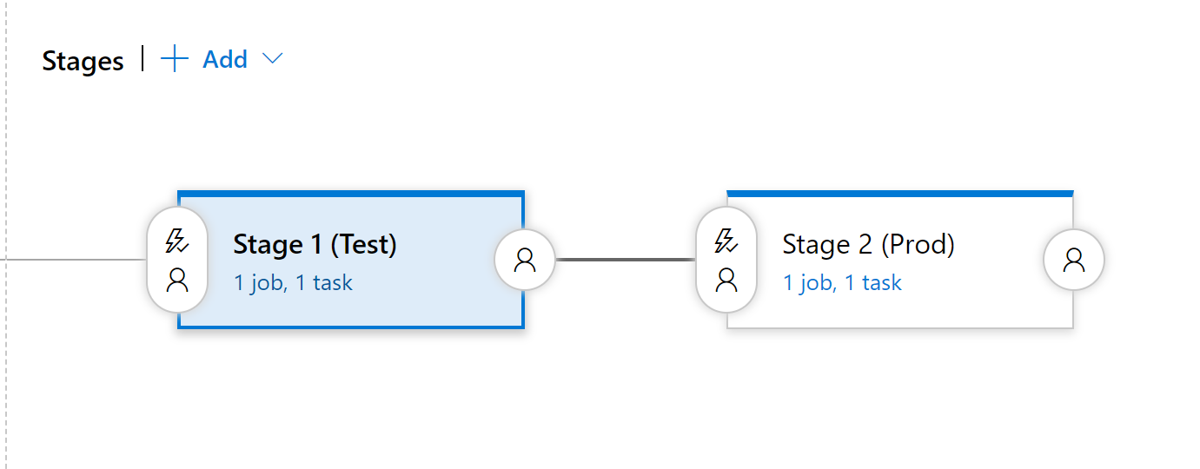

Note: If needed you can change your Azure subscription details by editing this stage.

Rename the release pipeline with appropriate.

Save the release pipeline.

**Deploy a release**

To run the Azure template on each stage, you can create a release or make a scheduled trigger.

Select release and click on Create a release.

Select which stage needs to be have conditions before deployment,  in my case production deployment (Stage (PROD)) .

Click pre- deployment conditions on Prod stage. select After stage of Stage 1 (Test).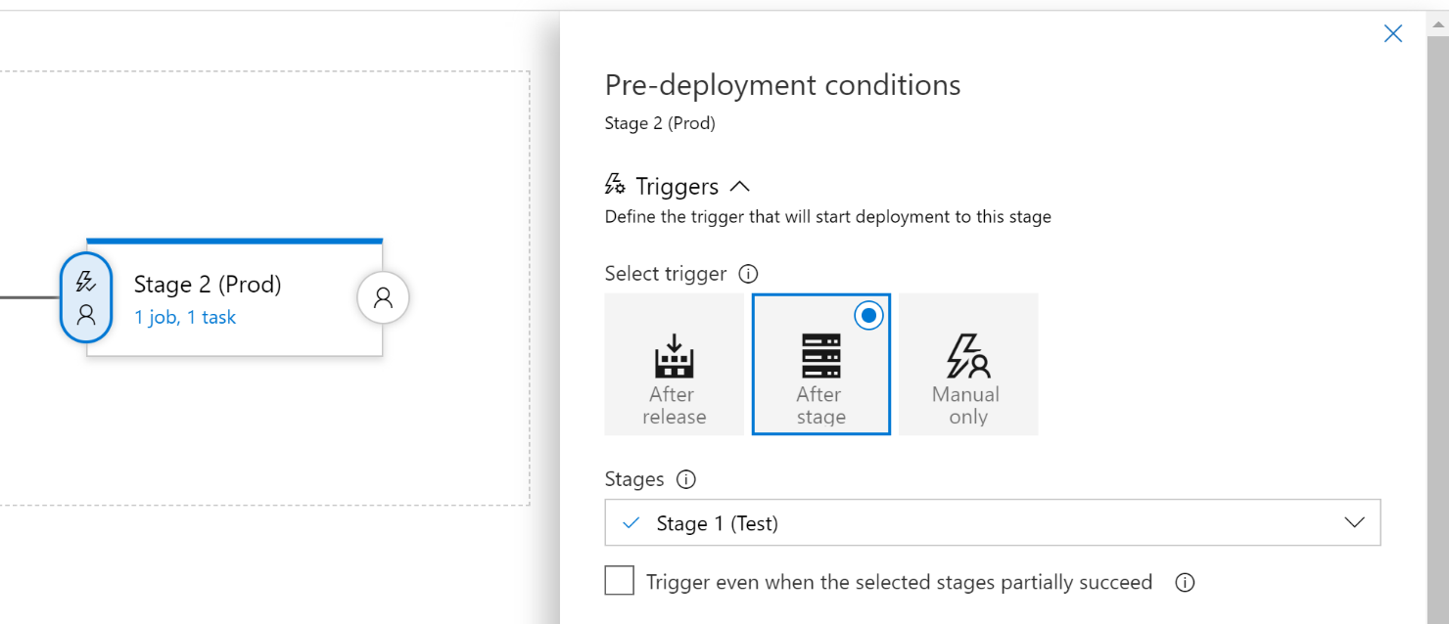

Click on create.

The release we have created will be deploying and you can check the resource on Azure or verify the logs.

If you need to perform multiple deploy, select pipeline and click on deploy, choose multiple deploy options.

After this production stage will have resourced mentioned on ARM template.

**Notes: Approvals** and **gates** give you additional control over the start and completion of the deployment pipeline. Each stage in a release pipeline can be configured with pre-deployment and post-deployment conditions that can include waiting for users to manually approve or reject deployments and checking with other automated systems until specific conditions are verified.

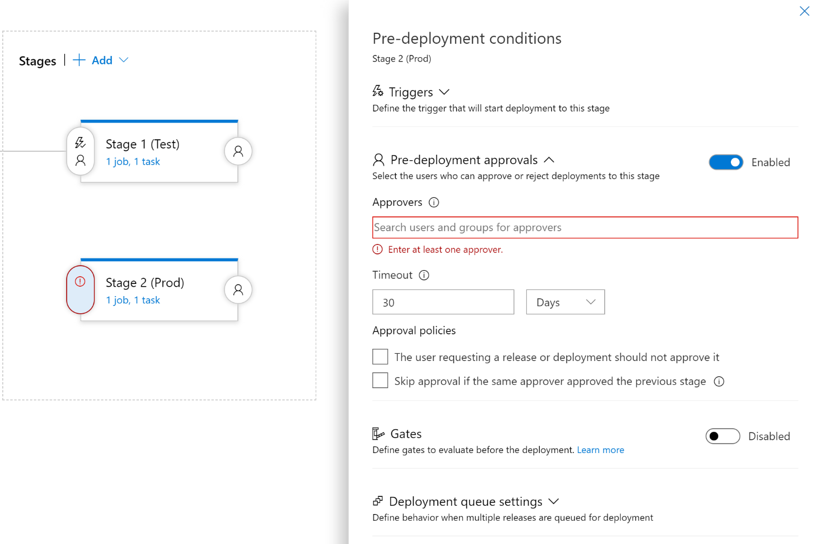

In addition, you can configure a manual intervention to pause the deployment pipeline and prompt users to carry out manual tasks, then resume or reject the deployment.